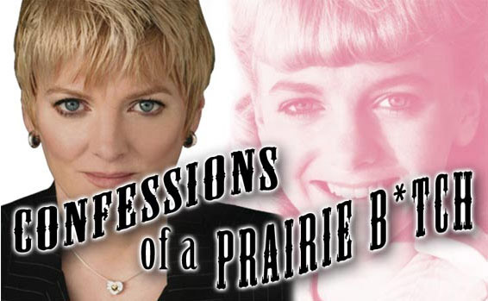

ALISON ARNGRIM

Bio in Brief

Alison Arngrim, best known to viewers world-wide for her portrayal of the incredibly nasty “Nellie Oleson” on the much loved, long running hit television series "Little House On The Prairie," continues to amuse audiences through her many film, television and stage appearances. She can currently be seen in the independent films “For the Love of May” with Ru Paul and Patricia Neal, and “The Last Place On Earth” with Billy Dee Williams and Phyllis Diller. She recently began her foray into French cinema with the role of “Edith” in the French detective comedy, Jean Pierre Mocky’s “Le Deal”.

In addition to her seven years on "Little House," Alison guested on such cult classics as: "The Love Boat," "Fantasy Island" and the NBC movie of the week, "I Married Wyatt Earp," starring Marie Osmond. She mocked her own status as an “ex-child star” on Jay Leno’s Tonight Show, during their month long parody, “Hollywood Survivor” and continues to be a frequent interview subject on everything from “A&E”, “E! Entertainment”, “TV Land” and “VH-1”, to CNN and the Travel Channel.

Alison’s stage work includes, “Sirena: Queen of the Tango”, "Butterflies Are Free," “Hidden In The Laughter”, "Dear Brutus," "The Wool Gatherer," "Cry Of Players", the French bedroom farce, "In One Bed And Out The Other," Michael Kearns’ “AIDS/US II,” and the role of “Rita” in the 2005 GLAAD Award nominated production of “Last Summer At Bluefish Cove.” Most recently she starred at the ACME Comedy Theatre in the Ovation Award Nominated musical-drama, “Flirting with Morty” as the abusive, trashy and tragic Ray Lee.

As a stand-up comedian, Alison has headlined at nightclubs such as the Laugh Factory, the Comedy Store and the Improv in Los Angeles; as well as the Cutting Room in New York and assorted comedy venues all across the United States and Canada.

Her one woman show “Confessions of a Prairie Bitch”, which started at Club Fez in New York, has now become a world-wide phenomenon, having been performed to packed houses in New York, Los Angeles, Seattle, Maui and the south of France, where Alison performed entirely in French to a standing room only crowd at the “Palais des Congres” in her all French version titled: “Confessions d’une Garce de La Prairie”!

In 1986 when her friend and "Little House husband" co-star, Steve Tracy, passed away due to complications of HIV/AIDS, Alison immediately began volunteering at AIDS Project Los Angeles. Her duties have ranged from working on the Southern California AIDS Hotline and the APLA food bank, (APLA's Necessities of Life Program) to chairing the steering committee of the volunteer speakers bureau and developing “Safer Sex” workshops. She has provided AIDS education to doctors, nurses, prison inmates, service clubs, churches, department stores and schools, and spent seven years hosting the APLA educational cable television show, "AIDS Vision". In 1992, Joel Wachs presented Alison with a resolution by the Los Angeles City Council commending her on her work on behalf of people living with HIV and AIDS. She continues to serve on the Ambassador Council of AIDS Project Los Angeles.

From 1989 through 1993 she served as Program Manager at Tuesday's Child, an organization assisting children and families affected by HIV and AIDS. From 1989 through 2003 she served as both hostess and producer for the comedy stage at the AIDS Project Los Angeles Annual Summer Party, (on the backlot of Universal Studios), where through an evening of raucous entertainment, featuring name comedians, she helped to raise hundreds of thousands of dollars for people living with HIV.

She currently serves on the National Advisory Board of The National Association to Protect Children (www.PROTECT.org), fighting to give children a legal and political voice in the war against child abuse. As an activist for the improvement of child protection laws, she has spoken before the California Senate and worked on legislative and political campaigns in several states, including Virginia and New York.

She has appeared on numerous television news programs discussing the legal and political issues surrounding child abuse and molestation, including Larry King Live, Nancy Grace, CNN’s Showbiz Tonight, The Insider, Court TV and Bill O’Reilly’s The Factor.

Alison currently lives in the wilds of Tujunga with her husband of thirteen years, musician Bob Schoonover, (from the rock and roll band “Catahoula”) and their two cats, Hannibal and Clarice. She takes pride in the fact that so many people enjoyed hating her as a girl and is more than happy to give them the opportunity to do so in the future.


